1. 
2. Let’s talk about the motivation behind Generics.
3. 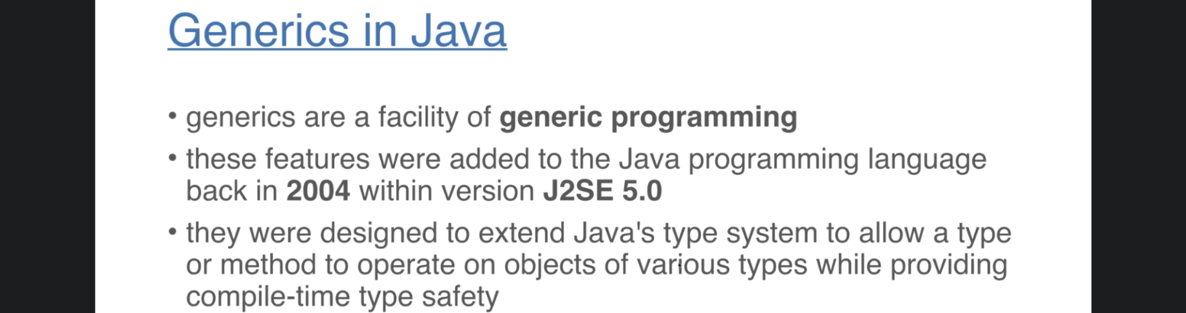
4. 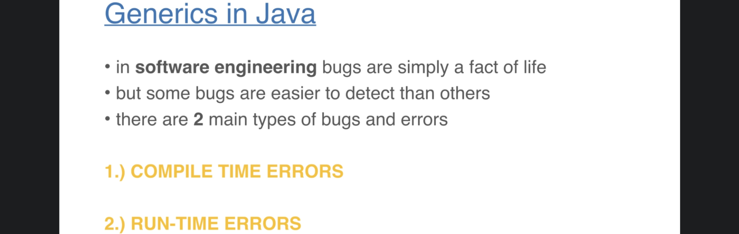
5. Let’s talk about these two types of Errors.
6. 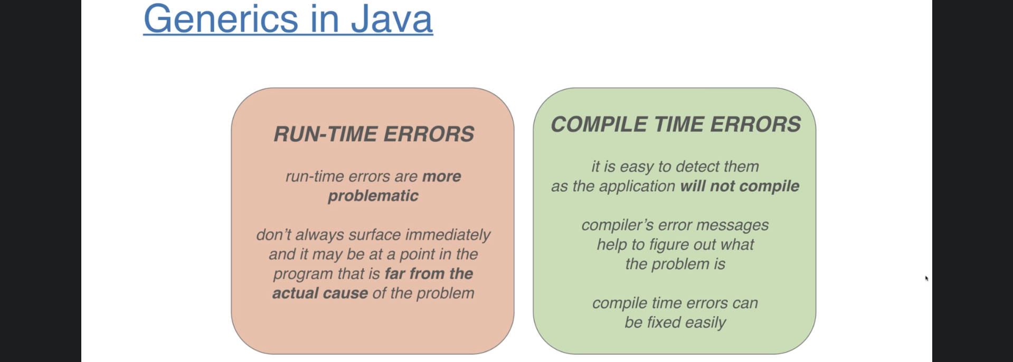
7. Why to use Generics?
8. 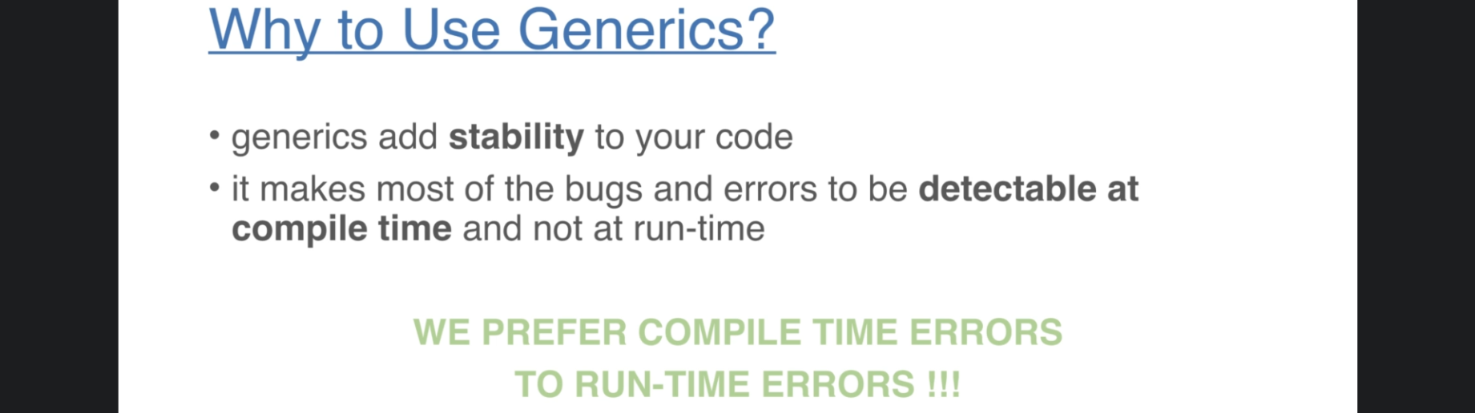
9. 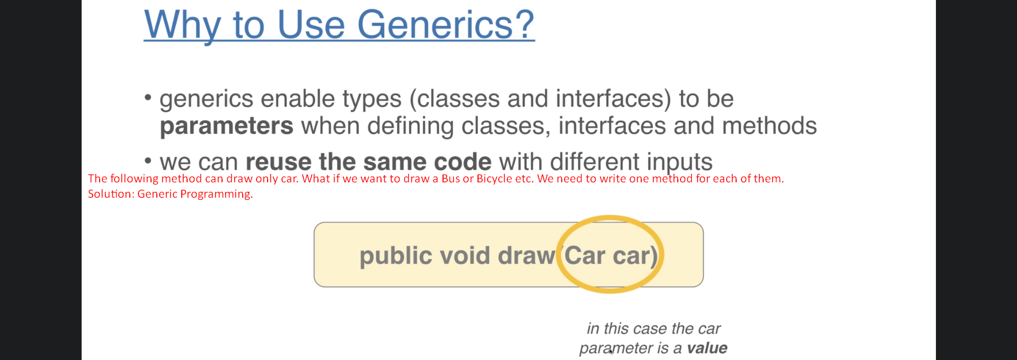
10. 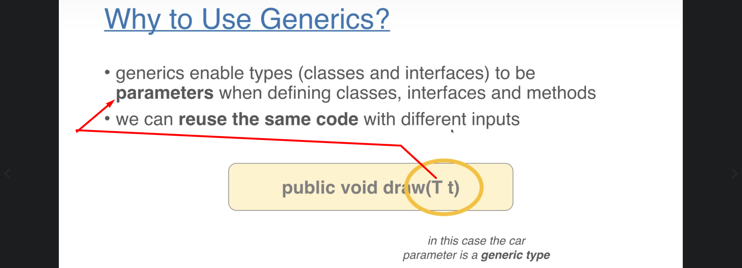
11. 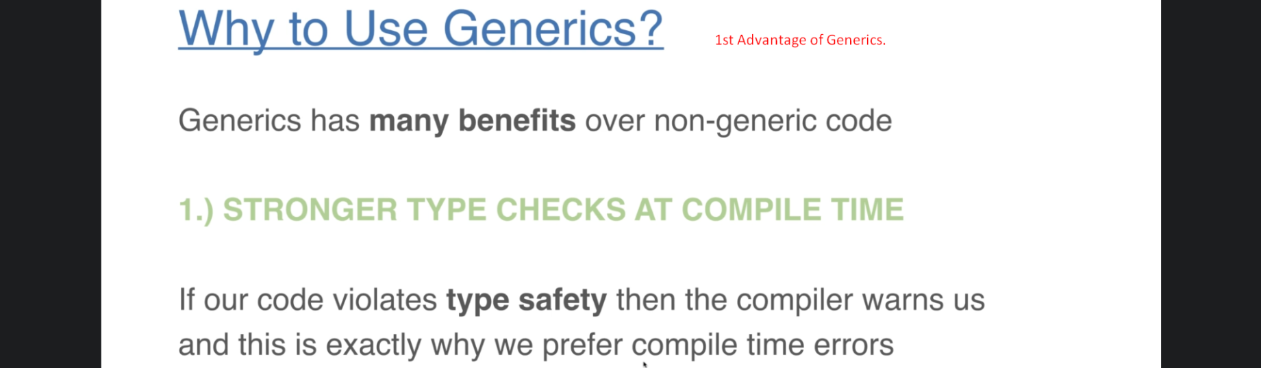
12. 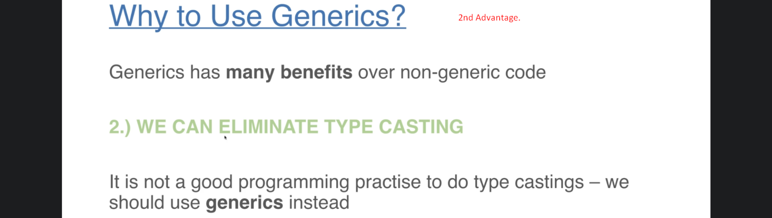
13. 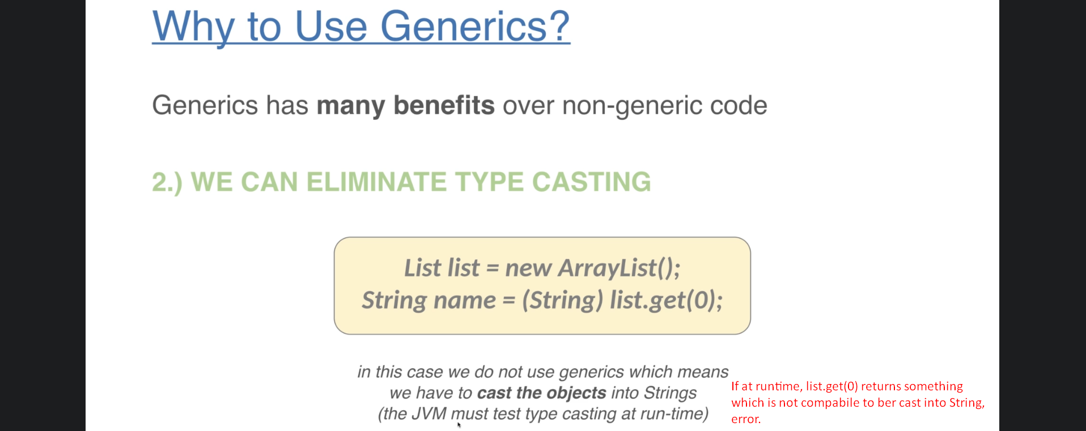
14. 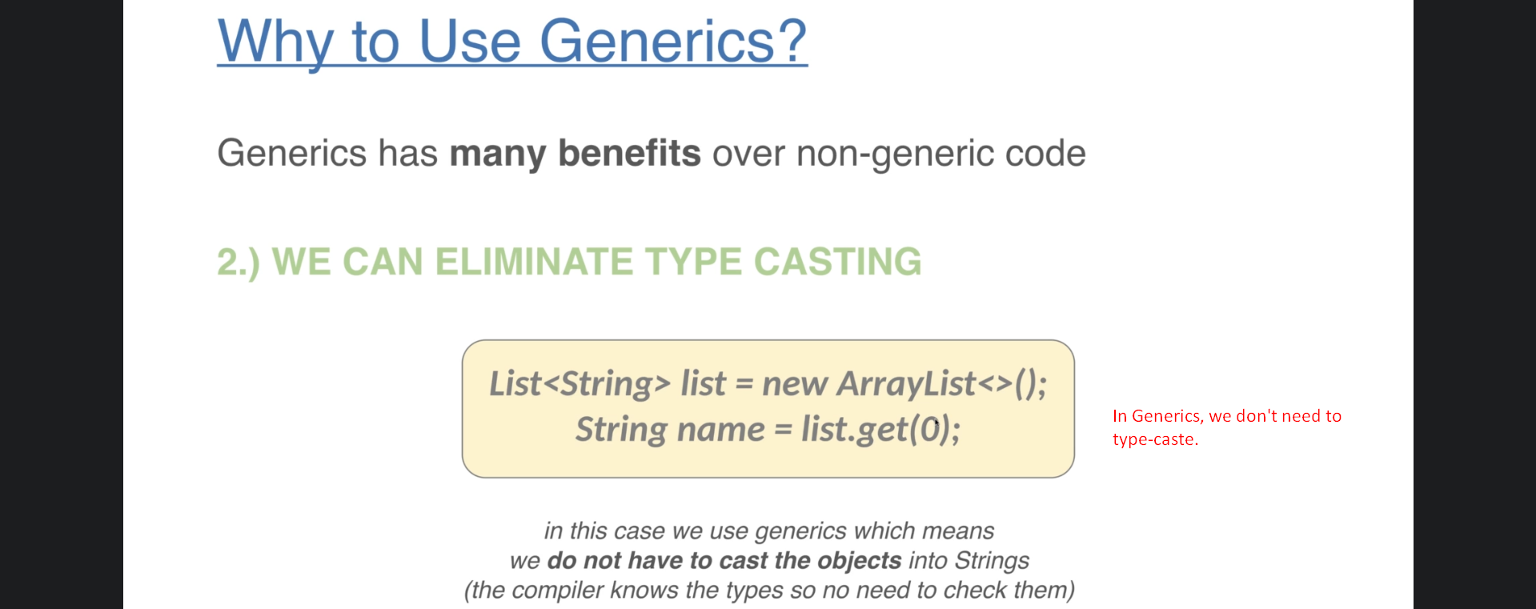
15. 